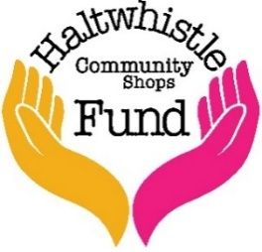
Haltwhistle Community Shops Fund
Application form
This application form is for grants of up to £10,000.
Before completing the form, please ensure you have read the Community Shops Fund Overview, Application Guidance, and Terms & Conditions to confirm your eligibility.
We also recommend that you save a copy of your completed application for your own records.

Section A: About your organisation/group

Organisation Name:
Address:

Postcode:
Website address: (if applicable)
Year Organisation was established:
Description of Organisation: | Community Group |  |  | Club
(Please tick appropriate box) | Society |  |  | Charity
 | Social Enterprise |  |  | Other (specify below)
Charity number: (if applicable)
Briefly describe your organisation’s purpose and main activities: (150 words max)
Are you a member of the Haltwhistle Partnership? |  |  | YES |  |  | NO
Does your organisation have a governing document? |  |  | YES |  |  | NO
Does your organisation have a bank or building society account with a minimum of two signatories? |  |  | YES |  |  | NO
If none, provide the name and contact details of the organisation fulfilling this role.
Provide a map or list of postcodes showing the geographical area your organisation serves

Section B: Your contact details: (These details will be used for correspondence)

Your name:
Position in organisation:
Address (if different to above)
Postcode:
Email address:
Telephone:
Please indicate any specific communication requirements we should be aware of when corresponding with you.

Section C: About your project

Project title:
Geographical location of the project:
Brief description of the project: (max 400 words)
AIMS
OBJECTIVES:
EXPECTED OUTCOMES:
Are any consents or permissions required for the project to proceed?
Are these permissions in place?
Expected start date of the project:
Expected date of completion:

Section C: About your project (continued)

Identify any potential problems or risks that could impact the delivery or success of the project and explain the measures you will take to overcome or mitigate them.
Based on your response above, please complete a Risk Assessment for your project using the template provided at the end of this document.
Risk Assessment Completed: | YES |  | NO
Explain how you have determined the local need for the project. (200 words max)
Please provide information on the level of community support for the project, including details of any consultations or surveys you have conducted. (if applicable)

Section C: About your project (continued)

Please describe who will benefit from the project:
Expected Attendance: |  |  | Age Range:
Special Characteristics: (if applicable)
Further Details: (200 words max)
Please explain the impact your project will have on the local community: (200 words max)
Explain how your project will continue to deliver lasting benefits for the local community after the initial funding has been used. (max 200 words)
Describe how you will monitor and evaluate the success and outcomes of your project.

Section D: Budget

Total project cost: | £
Amount sought from this Fund: | £
The amount of funding your organisation will contribute toward the total cost of the project: | £
Please use Table 1 to itemise your anticipated expenditure:
Table One
Item/Activity | Description | Cost
 |  | £
 |  | £
 |  | £
 |  | £
 |  | £
 |  | £
 |  | £
 |  | £
 |  | £

How have you arrived at these costs:
Please complete Table 2 if you have secured funding from any other organisations for this project:
Table 2
Organisation | Date of award | Cost

If applying for capital funding, specify who will maintain the equipment or materials after project completion and what this will involve.
If applying for revenue funding, explain what will happen when the funding period ends.
Section E: Additional Information

Provide any additional information that may support your application: (150 words max)

Section F: Safeguarding Policy

Please confirm that your organisation has a Safeguarding Policy or Policies for the protection of children and/or vulnerable adults (where applicable), that the policy is actively followed, and that all staff and volunteers working with these groups have undergone appropriate DBS checks.
Safeguarding Policy Confirmation: | YES |  | NO

Declarations
The information provided in this application form will be held and processed in accordance with the General Data Protection Regulation (GDPR) 2018. It will be used solely by the Haltwhistle Partnership for the purposes of grant processing, analysis, auditing, and evaluation. This information will not be used for any other purpose, published on our website, or shared with any other agencies or organisations.
By submitting this application to the Community Shops Fund, I acknowledge and agree to the following conditions:
- I confirm that, to the best of my knowledge and belief, the information provided above is accurate and true.
- I understand and accept that the Haltwhistle Partnership Administrator and Board of Trustees have a legal and ethical responsibility to carry out due diligence in relation to grant allocations. I will provide all necessary documentation required to enable the Haltwhistle Partnership to meet this obligation.
- I understand that if the requested supporting documentation is not provided, this application cannot be assessed against the designated criteria required for informed decision-making.
- I understand that only information relevant to the evaluation of this application will be submitted to the Community Shops Fund Grants Panel to support their recommendations.
- If this application is successful, I guarantee that the funds will be used exclusively for the purposes outlined in this application.
- I understand that the Haltwhistle Partnership reserves the right to request repayment of any grant funds that are not used for the intended purpose.
- I understand that the Haltwhistle Partnership’s Insurance, Safeguarding, and Risk Assessment Policies apply only to projects directly administered by the Haltwhistle Partnership and do not cover activities funded by the Community Shops Fund grant.
- I understand that if this grant is approved, I will provide a project risk assessment, a bank statement in the name of the applicant organisation, as well as our safeguarding and insurance policies, if these were not submitted with the application.
- I understand that failure to provide the required supporting documentation will result in the withdrawal of the grant offer.
- I understand that the funding is provided for a specified period only, and a final report must be submitted upon project completion for monitoring and review purposes.
- I understand that failure to submit a final report to the Haltwhistle Partnership may result in a request for repayment of the funding and the rejection of future funding applications.
- I understand that details of the grant award may be shared with the media, published on social media platforms, and included in the Haltwhistle Partnership’s press releases.
- If successful, I agree to acknowledge the support of the Community Shops Fund in all publicity and promotional materials, including the use of the Community Shops Fund logo and reference to the Haltwhistle Community Shops Fund.
- I understand that failure to complete any section of this application form or provide the required documentation, without a reasonable explanation, will result in the application being returned.
Signature: |  | Date:

Signatures:

This application form should only be submitted if you are properly authorised to do so on behalf of your organisation.
Signature 1: |  | Date:
Position:
Signature 2: |  | Date:
Position:
Application Checklist

Document | Included
Constitution, rules or governing document
Completed Risk Assessment
Safeguarding policy (if applicable)
Two Quotes (if applicable)
Letter of recommendation/support (Optional)
Map of area of service (if applicable)
Other (please specify)
Supporting Documentation required prior to grant release

Document | Included
Bank statement with named organisation
Insurance Policy
Safeguarding policy (if applicable)
Risk Assessment (if applicable)
Other (please specify)

Submission of form:

Send your completed application form and supporting documents to:
Shops Fund Administrator
Email Address: | shopsfund@haltwhistle.org
Postal Address: | Westbourne House,  Main Street,  Haltwhistle, NE49 0AZ
Upon receipt of your application, you will receive a confirmation email.
If you do not receive this email, please contact the Fund Administrator using the email or postal address provided above.
If you require any assistance with your application, please feel free to contact the Shops Fund Administrator.
Phone Number: | 04134 321242
For further information about the Community Shops Fund or the Haltwhistle Partnership please contact:
Haltwhistle Partnership Administrator
Email Address: | admin@haltwhistle.org
Phone Number: | 01434 321242
Postal Address: | Westbourne House  Main Street,  Haltwhistle, NE49 0AZ

Please let us know how you heard about the Community Shops Fund? | Tick
Facebook
Haltwhistle Partnership Website
Poster/leaflet
Local Press
Direct email
Word of mouth
Other (please specify

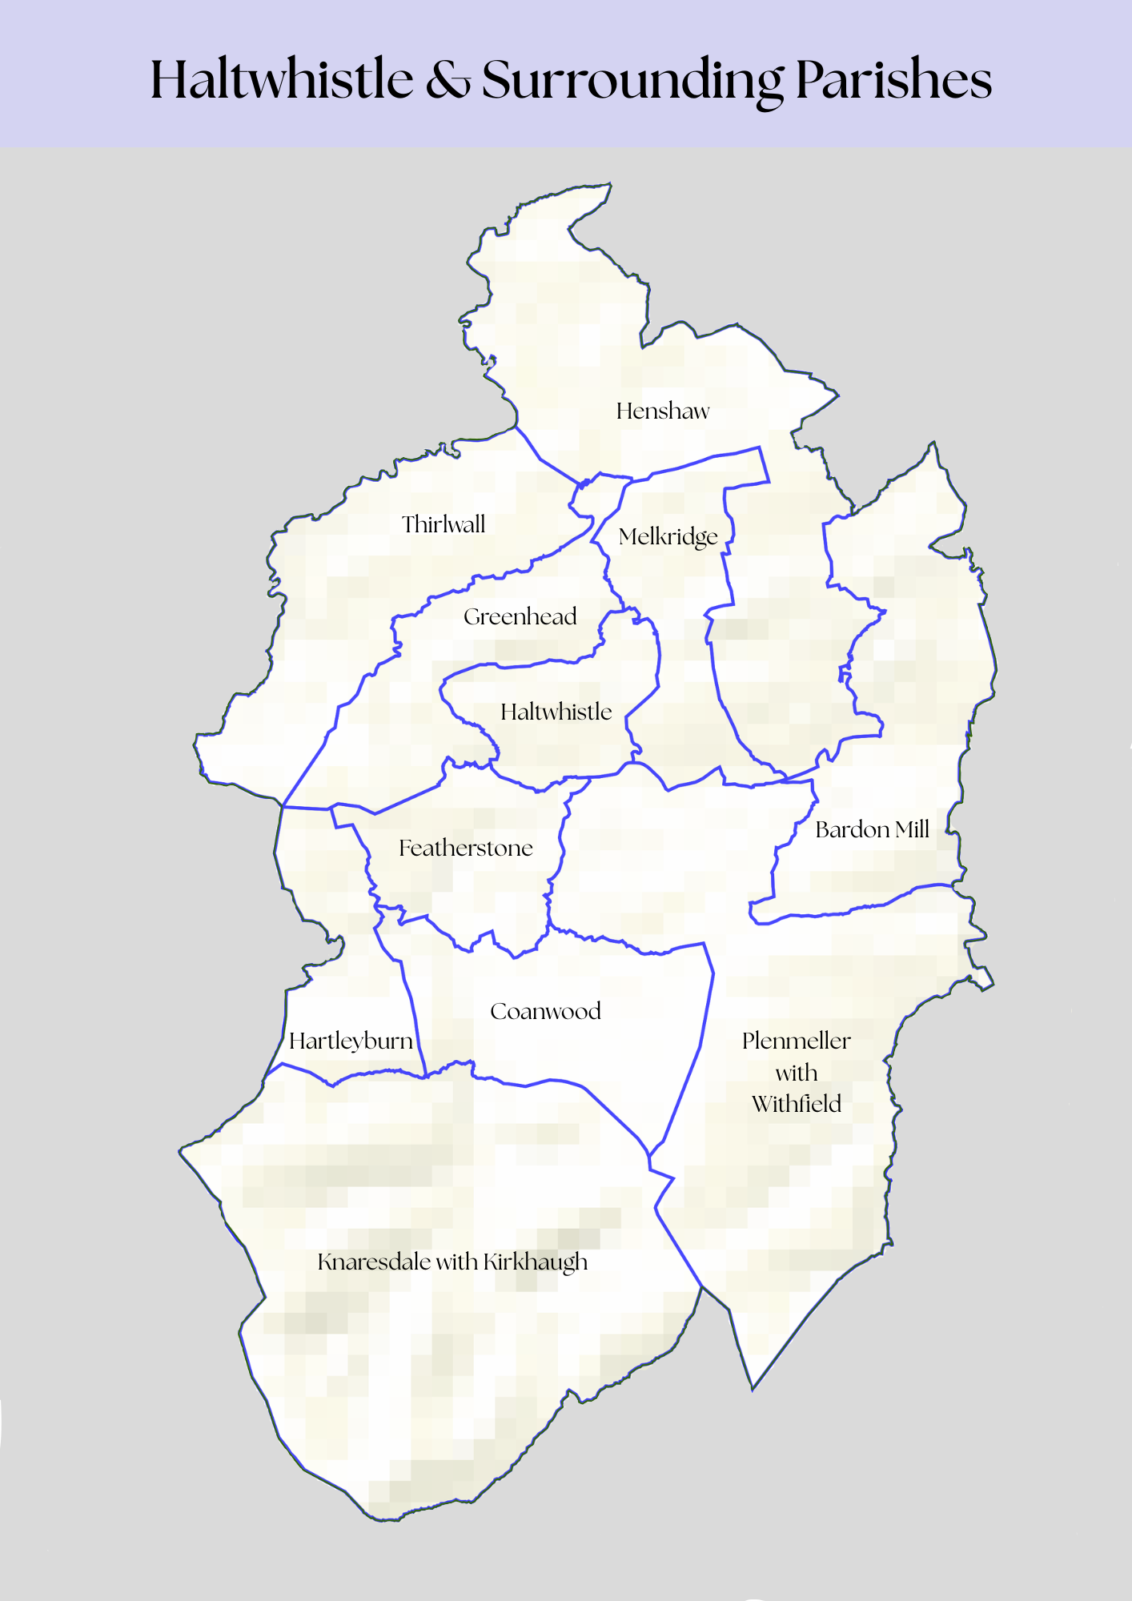

Project Risk Assessment
This risk assessment aims to identify potential risks associated with the project’s activities and ensure that adequate measures have been taken to minimize them.
Project Name:
In conducting this exercise, the following steps were followed:
- Identify the areas to be reviewed
- Identify the risk associated with the areas identified
- Evaluate the existing management and control of the risk and record all findings
- Identify additional mitigation measures to reduce the risk to its lowest acceptable level
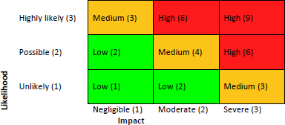
The level of risk for each activity was identified using the 3 X 3 matrix opposite.
- Likelihood was defined as the possibility of a potential risk occurring.
- Impact was defined as the consequence or effect of the risks.

Subject | Risk(s) Identified | Likeli- hood | Impact | H/M/L | Management/  Control of Risk | Risk Owner
(Examples)  Financial Management | Misuse of grant funds  Repayment of grant  Refused further funding applications | 1 | 3 | M | Financial Control Policy  2 signatories for accounts  Regular reporting of accounts | Account Manager
Environmental | Environmental harm caused by project | 1 | 2 | L

